Test Case: tc002_SPX_Dev5_Crear_Requisicion_Spot_Tipo_Cobro_Project
Step 1 - Enter username and password and click to button Enter: Credentials Entered
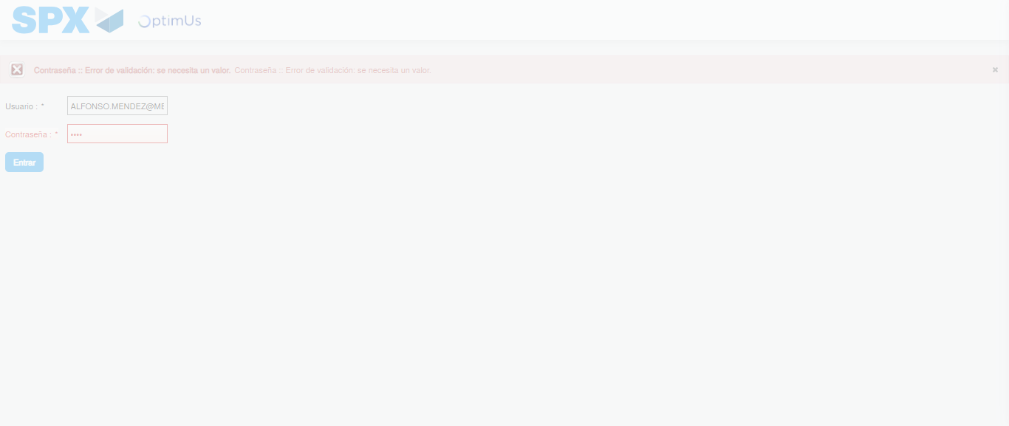Image file-name: QC_Testing-tc002_SPX_Dev5_Crear_Requisicion_Spot_Tipo_Cobro_Project-1783361402447

Step 2 - Select to UEN and Access to Spot Buy Requisitions : UEN Correctly selected and Correct access
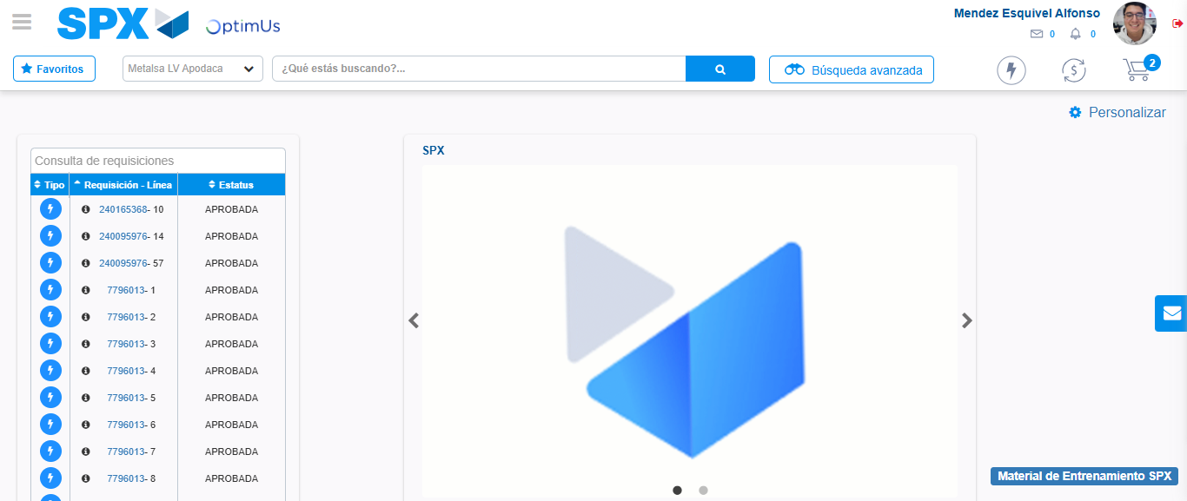Image file-name: QC_Testing-tc002_SPX_Dev5_Crear_Requisicion_Spot_Tipo_Cobro_Project-1783361428054

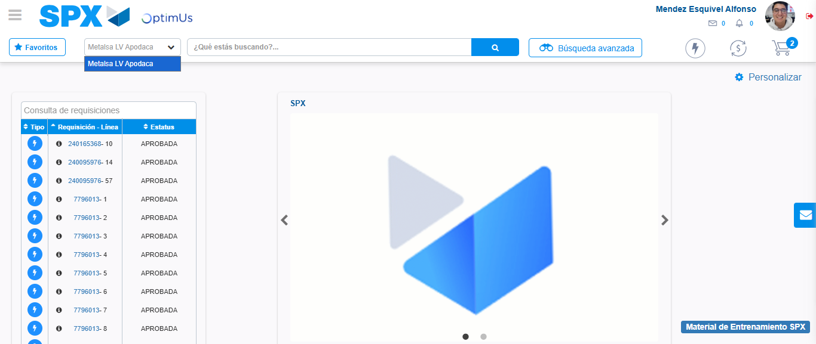Image file-name: QC_Testing-tc002_SPX_Dev5_Crear_Requisicion_Spot_Tipo_Cobro_Project-1783361430626

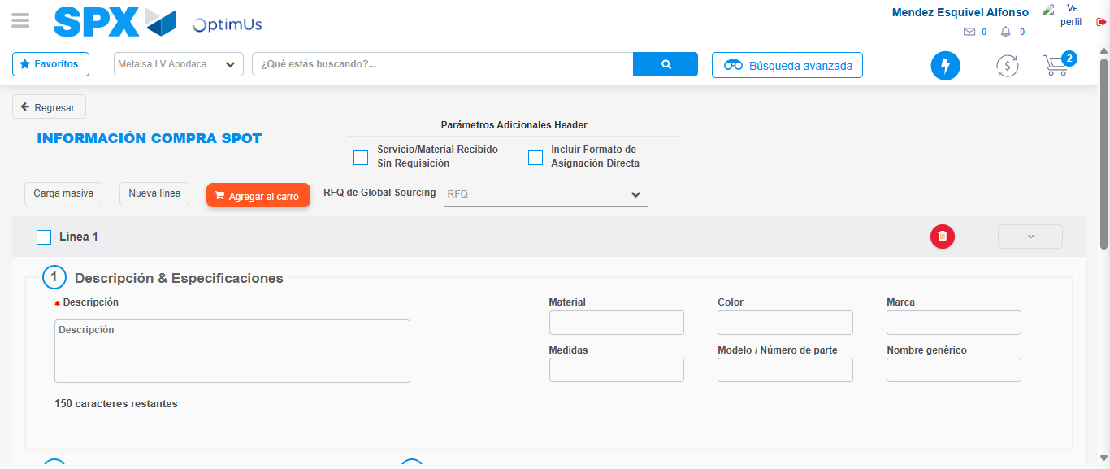Image file-name: QC_Testing-tc002_SPX_Dev5_Crear_Requisicion_Spot_Tipo_Cobro_Project-1783361452897

Step 3 - Data Capture Spot Buy Requisition: Data captured correctly
Image file-name: QC_Testing-tc002_SPX_Dev5_Crear_Requisicion_Spot_Tipo_Cobro_Project-1783361453133

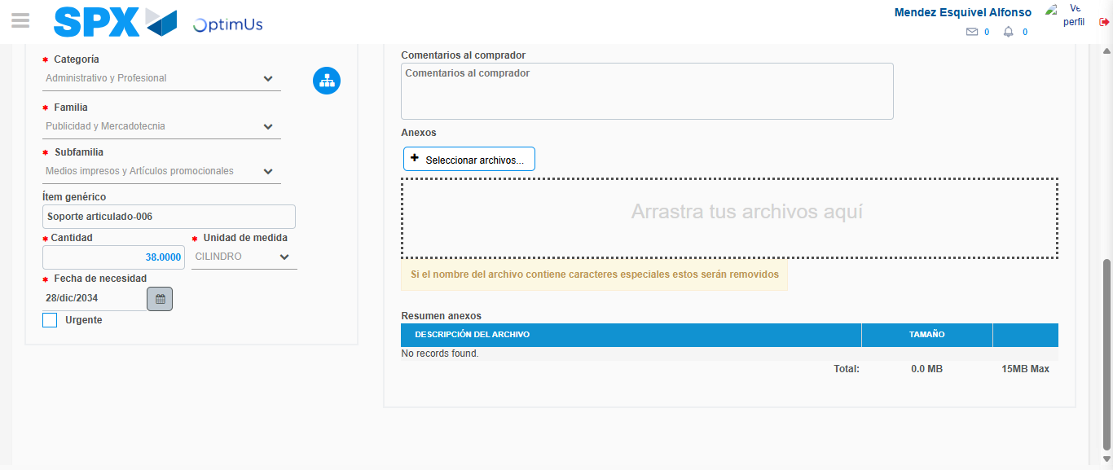Image file-name: QC_Testing-tc002_SPX_Dev5_Crear_Requisicion_Spot_Tipo_Cobro_Project-1783361462775

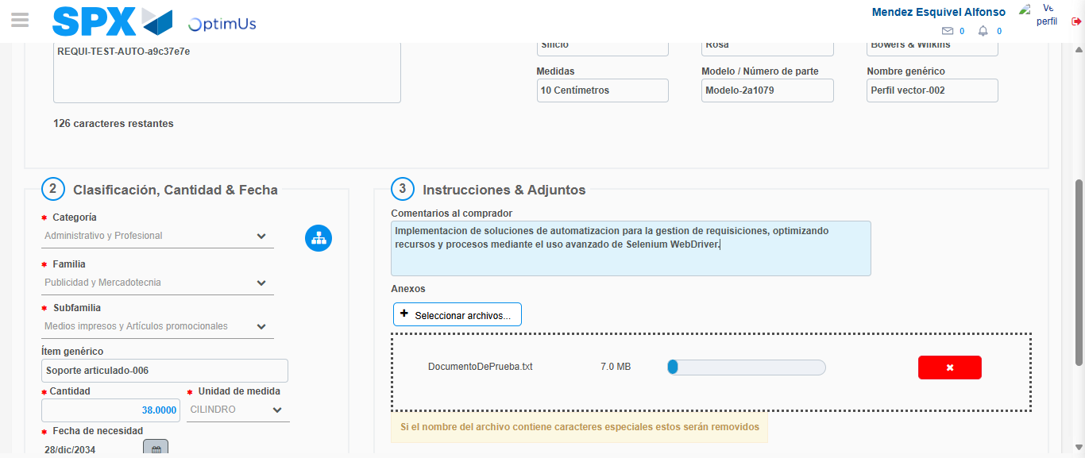Image file-name: QC_Testing-tc002_SPX_Dev5_Crear_Requisicion_Spot_Tipo_Cobro_Project-1783361463533

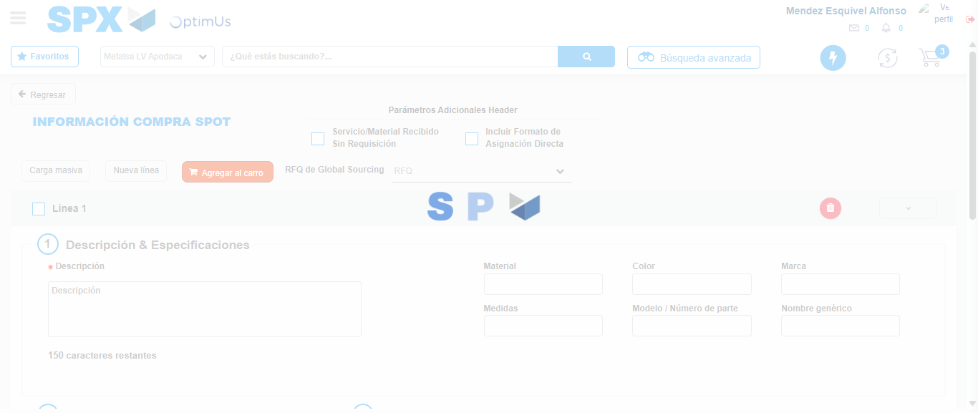Image file-name: QC_Testing-tc002_SPX_Dev5_Crear_Requisicion_Spot_Tipo_Cobro_Project-1783361469938

Step 7 - Return to Main Page SPX : Return to Main Page SPX
Image file-name: QC_Testing-tc002_SPX_Dev5_Crear_Requisicion_Spot_Tipo_Cobro_Project-1783361428054

Image file-name: QC_Testing-tc002_SPX_Dev5_Crear_Requisicion_Spot_Tipo_Cobro_Project-1783361430626

Image file-name: QC_Testing-tc002_SPX_Dev5_Crear_Requisicion_Spot_Tipo_Cobro_Project-1783361452897

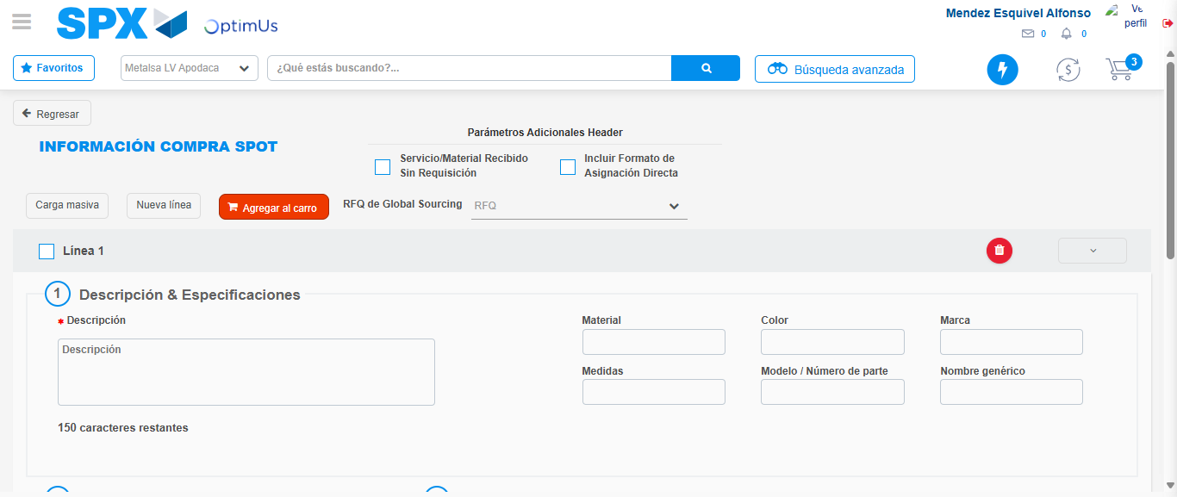Image file-name: QC_Testing-tc002_SPX_Dev5_Crear_Requisicion_Spot_Tipo_Cobro_Project-1783361472185

Image file-name: QC_Testing-tc002_SPX_Dev5_Crear_Requisicion_Spot_Tipo_Cobro_Project-1783361472348

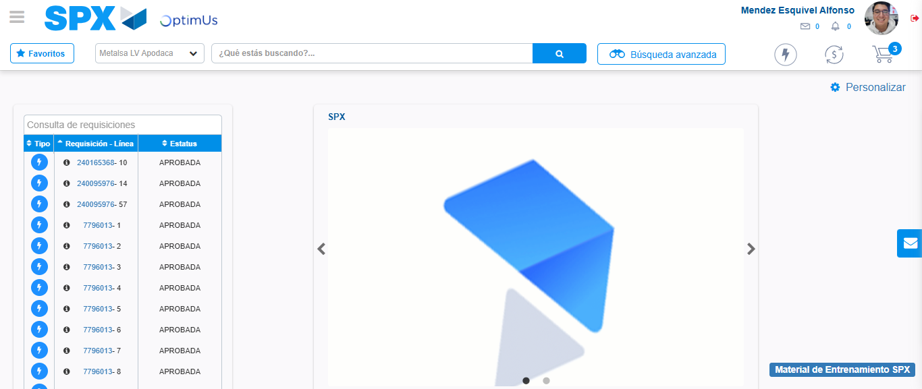Image file-name: QC_Testing-tc002_SPX_Dev5_Crear_Requisicion_Spot_Tipo_Cobro_Project-1783361493668

Step 8 - Log Out : Log Out SPX
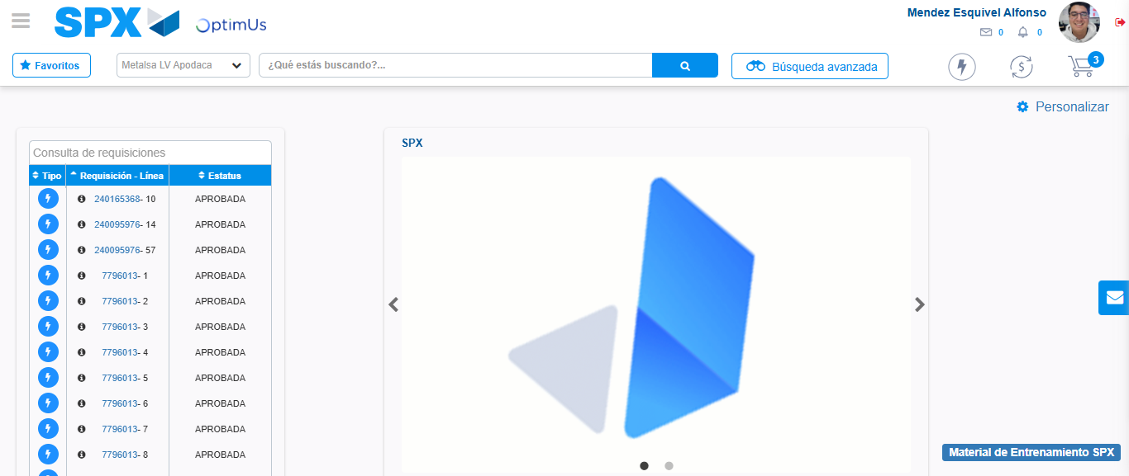Image file-name: QC_Testing-tc002_SPX_Dev5_Crear_Requisicion_Spot_Tipo_Cobro_Project-1783361494013

